Exp No: 4 Date: 12/09/2020

CHAT USING TCP Name: Swetha Saseendran

Register Number: 185001183

## **Code:**

**SERVER.C**

#include<netdb.h>

#include<stdio.h>

#include<stdlib.h>

#include<string.h>

#include<sys/socket.h>

#define MAX 80

#define PORT 8080

#define SA struct sockaddr

int clientCount = 1;

void error(char *msg)

{

    perror(msg);

    exit(1);

}

void chat(int sockfd,int connfd,int clientIndex)

{

    char buff[MAX];

    int n;

    while(1)

    {

        //Clear buffer

        bzero(buff,sizeof(buff));

        //Read message from client

        read(connfd,buff,sizeof(buff));

        if(strncmp("exit",buff,4)== 0)

        {

            printf("\nCLIENT %d LEFT THE CHAT\n",clientIndex);

            break;

        }

        else

            printf("\nClient %d: %s\n",clientIndex,buff);

        //Write message to client

        n = 0;

        bzero(buff,MAX);

        printf("Server: ");

        while((buff[n++] = getchar())!='\n');

        if(strncmp("exit",buff,4)== 0)

        {

            printf("\nSERVER EXITS\n");

            close(sockfd);

        }

        write(connfd,buff,sizeof(buff));

    }

}

int main()

{

    int sockfd,connfd,pid;

    struct sockaddr_in servaddr,cli;

    char buff[MAX];

    int n = 0 , len;

    //Socket creation and verification

    sockfd = socket(AF_INET,SOCK_STREAM,0);

    if(sockfd == -1)

        error("Socket creation failed.\n");

    //Reset Server Address

    bzero(&servaddr,sizeof(servaddr));

    //Assign IP,PORT

    servaddr.sin_family = AF_INET;

    servaddr.sin_addr.s_addr = inet_addr("127.0.0.1");

    servaddr.sin_port = htons(PORT);

    //Binding to port

    if((bind(sockfd,(SA*)&servaddr,sizeof(servaddr)))!=0)

        error("Address Failed Binding.\n");

    //Listen for client

    if(listen(sockfd,5)!=0)

        error("Listening Failed.\n");

    while(1)

    {

        //Accept client

        len = sizeof(cli);

        connfd = accept(sockfd,(SA*)&cli,&len);

if(connfd<0)

            error("Not Accepted.\n");

        else

            printf("\nCLIENT %d ENTERED THE CHAT\n",clientCount);

        pid = fork();

        if (pid == -1) //error

        {

            close(connfd);

            error("Error in creating process\n");

            continue;

        }

        else if(pid > 0)

        {

            close(connfd);

            clientCount++;

            continue;

        }

        else if(pid ==0){

            //Chat function

            chat(sockfd,connfd,clientCount);

            //close(connfd);

            bzero(buff,MAX);

            break;

        }

        close(sockfd);

    }

}

**CLIENT.C**

#include<netdb.h>

#include<stdio.h>

#include<stdlib.h>

#include<string.h>

#include<sys/socket.h>

#define MAX 80

#define PORT 8080

#define SA struct sockaddr

void error(char *msg)

{

    perror(msg);

    exit(1);

}

void chat(int sockfd)

{

    char buff[MAX];

    int n = 0;

    printf("\n");

    while(1)

    {

        n = 0;

        bzero(buff,sizeof(buff));

        printf("Client: ");

        while((buff[n++] = getchar())!='\n');

        if(strncmp("exit",buff,4)== 0)

        {

            printf("\nCLIENT EXITS\n");

            write(sockfd,buff,sizeof(buff));

            break;

        }

        write(sockfd,buff,sizeof(buff));

        //read from server

        bzero(buff,sizeof(buff));

        read(sockfd,buff,sizeof(buff));

        if(strncmp("exit",buff,4)== 0)

        {

            printf("\nSERVER LEFT THE CHAT\n");

            break;

        }

        else

            printf("\nServer: %s\n",buff);

    }

}

int main()

{

    int sockfd,server_fd;

    struct sockaddr_in servaddr,cli;

    char buff[MAX];

    int n = 0;

    //Socket creation and verification

    sockfd = socket(AF_INET,SOCK_STREAM,0);

    if(sockfd == -1)

    {

        printf("Socket creation failed..!\n");

        exit(0);

    }

    bzero(&servaddr,sizeof(servaddr));

    //Assign IP,PORT

    servaddr.sin_family = AF_INET;

    servaddr.sin_addr.s_addr = inet_addr("127.0.0.1");

    servaddr.sin_port = htons(PORT);

    //Connection

    if(connect(sockfd,(SA*)&servaddr,sizeof(servaddr))!=0)

    {

        printf("Connection Failed..\n");

        exit(0);

    }

    //Chat function

    chat(sockfd);

    close(sockfd);

}

**Sample Input Output:**

**SERVER SIDE:**

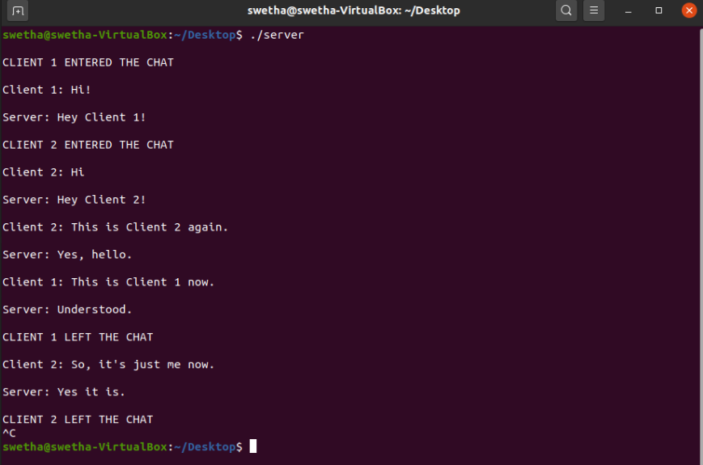

**CLIENT SIDE:**

Client 1:

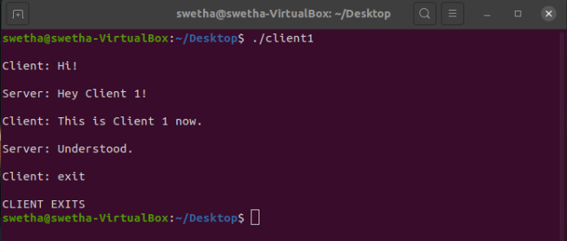

Client 2:

